**WEEK-8- Handson**

1. **GIT-HOL**

**Output Screenshots :**

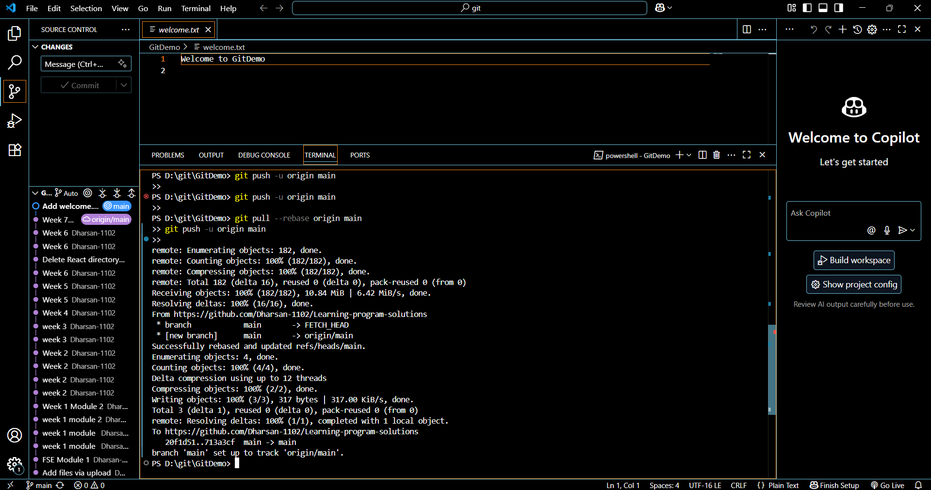

1. **GIT-HOL**

**Output Screenshots :**

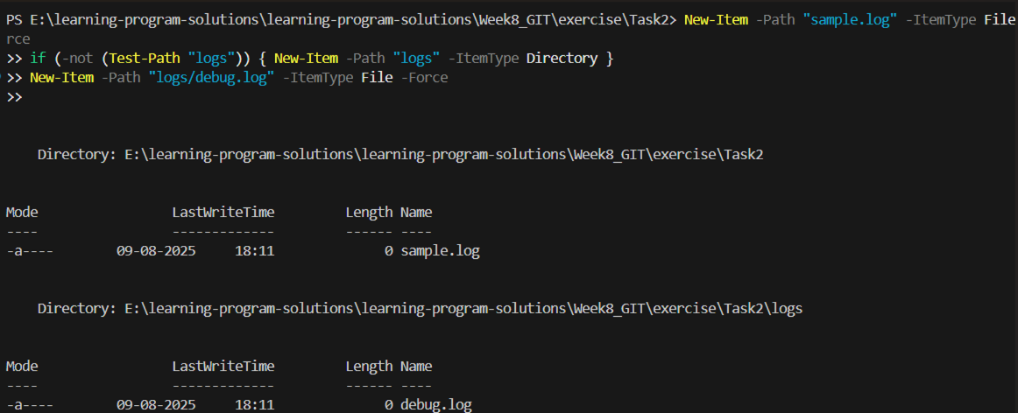

1. **GIT-HOL**

**Output Screenshots :**

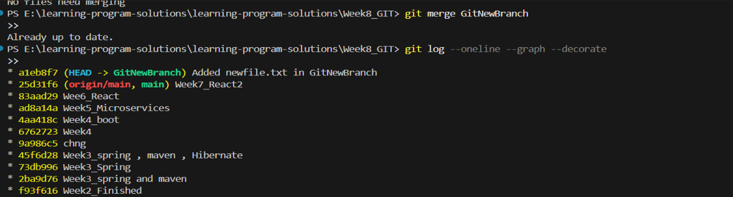

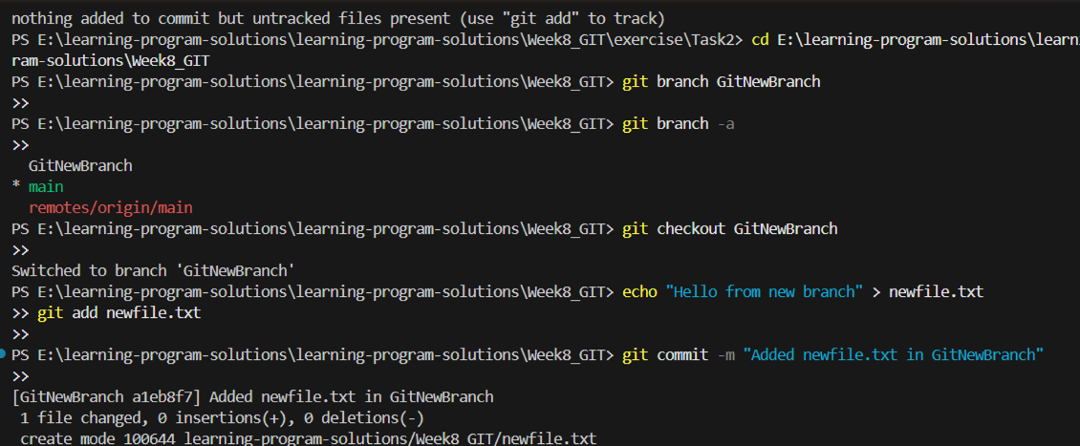

1. **GIT-HOL**

**Output Screenshots :**

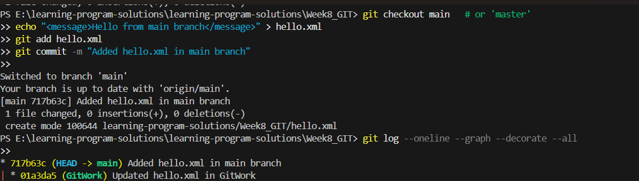

1. **GIT-HOL**

**Otuput Screenshots :**

